**QUIZ**

Quiz is an important activity in moodle. It facilitates the teacher to create quizzes consisting of a variety of q[uestion types](https://docs.moodle.org/37/en/Question_types) such as multiple choice, true-false, short answer and drag and drop images and text. Once created, the questions are kept in the [Question bank](https://docs.moodle.org/37/en/Question_bank) and can be re-used in different quizzes.

The quiz activity consists of four steps: (1) Setting up of quiz activity, (2) Creation of questions, (3) Adding questions to the quiz, and (4) Reviewing the Quiz.

1. **Setting up of quiz activity**
2. Access the course main page and turn **editing on.** Select **Add an Activity or Resource** link from the location where you want to insert the **Quiz** Activity.
3. From the activity chooser select **Quiz**
4. Enter a meaningful **name** for the quiz and add **description**, if any
5. Under **Timing** mention the **Open**ing and **Clos**ing time of the quiz. i.e. the period of availability for attempting the quiz by the students.

If required, **time limit** can be specified for completing the quiz once he or she has started it. The time required for completing a quiz depends on level of complexity of the quiz and the number of questions. The time limit can range anywhere from a number of seconds to a number of days.. Any one of the three options can be selected when the time limit expires: (a) A *grace period can be set facilitating the submission of open attempts*, (b) *Automatic submission of open attempts without grace period*, (c) *Attempts should be submitted before time expires, otherwise it will not accept*.

1. Under **Grade,** decide the **Grade Category, Grade to pass, Attempts allowed** and **Grading Method**

The **attempts allowed** is the number of attempts that the teacher can permit to take the quiz. This means that once the student has already taken the quiz, he or she can go back and take the quiz over and over again until he or she has reached the maximum number of attempts. The student can be allowed a single attempt or an unlimited number of attempts. The **Grading Method** is applicable only when the teacher set the *Attempts Allowed* as more than one. In that case the teacher has to decide how to calculate the final quiz grade. The self-explanatory options are **Highest Grade**, **Average Grade**, **First Attempt**, and **Last Attempt**.

1. Under **Layout**
2. Use the **New Page** option todecidethe number of questionsin one page. In order to display all the questions in one page, select the first option from the dropdown menui.e. **Never, all questions on one page.**
3. The **Navigation method** can be **Free** or **Sequential.** In case of **Sequential,** the student can attend the questions in order, i.e. first the question followed by 2 like that. Whereas in case of **Free**, they are permitted to progress through any question.
4. Under **Question behaviour**:
5. Decide whether **shuffling within a question** is permitted or not. This is applicable in *multiple-choice questions* and if the teacher permits more than one attempt. If *shuffling* is permitted, the answer options for a multiple-choice question can be randomly shuffled each time a student attempts the question.
6. Choose one of the seven **Question behaviours** from the dropdown menu.The **Question behaviour** allows the teacher to define what will happen after the student answers each question. The seven types of question behaviours are: Adaptive Mode, Adaptive Mode (*penalty*), Deferred Feedback, Deferred Feedback with CBM, Immediate Feedback, Immediate Feedback with CBM, and Interactive with Multiple tries.

**Deferred Feedback**: By default, the question behaviour is set to “**Deferred Feedback**. If a quiz uses Deferred feedback, the student has to answer all the questions and submit the quiz in order to get the feedback. The deferred feedback replicates a traditional examination.

**Deferred Feedback with CBM:** The CBM stands for Certainty Based Marking**.**  If the Teacher selects the Deferred Feedback with CBM, the system will ask the student how certain they are of the answer. Their certainty value will change the credit/ grade or penalty they receive for that specific question.

**Adaptive mode (penalty):** In **Adaptive Mode**, the students can have multiple attempts at each question before moving on to the next question. The question can adapt itself to the student's answer, for example by giving some hints before asking the student to try again. How many attempts the student gets is determined by how much the teacher penalize the student for each wrong attempt. For example, assume that the teacher penalize the student 50 percent for a wrong answer. If the student gets a question wrong, then he can try once more for half points. If the student gets the second attempt correct, they get half credit. If they get it wrong, the system subtracts another 50 percent from the score. Now, the question is worth zero points. The system will not display the question again for a third attempt, because it's now worth zero points.

**Adaptive mode***:* While the **Adaptive mode** (**Penalty**) subtracts a penalty for each wrong attempt the **Adaptive mode** does not.

**Immediate Feedback & Immediate Feedback with CBM**: In case of **Immediate feedback**, the student submits each question as they answer it. The quiz immediately displays a message based on the student's answer. The teacher can create separate feedback messages for any wrong answer, for any right answer, and/or a general feedback for the question, regardless of the answer. However, they can only submit one response, they cannot change it later.

**Interactive with multiple tries**: When the teacher make a quiz **Interactive with multiple tries**, it allow the student to try each question multiple times until they get correct answer. After each wrong attempt, the system will display a message. (*The teacher has to create relevant messages for each attempt).* This differs from Adaptive mode, which allows multiple attempts but no feedback.

1. **Each attempt builds on the last** option is applicable only if multiple attempts are allowed. When this setting is enabled, each attempt that a student makes will display the results of the student's previous attempt. The student can see how they answered and scored on the previous attempt.

Note: The setting for *Each attempt builds on the last* is useful when the teacher is using a quiz as a teaching tool or practising tool, instead of an evaluation tool. The Attempts allowed option allows the student to keep trying the quiz. Each attempt builds on the last retains the answers from one attempt to another. Taken together, these two settings can be used to create a quiz that the student can keep trying until they get it right

1. **Review Options**

This section is connected to the quiz behaviour settings and determines what information will appear when students review their past attempts at the quiz (and **During the quiz** in adaptive mode). Check all options you would like to be available for the student to review. "**Immediately after the attempt**" refers to directly after the quiz is attempted. "**Later, while the quiz is still open**" refers to while the time period for the quiz is still open but the quiz has been submitted.

1. There is an option to display student’s image Under **Appearance** the Student’s and decimal places in grades can be decided.
2. **Extra restrictions on attempts** can be made by setting password, network address enabled access and browser security (*These settings may be ignored*).
3. **Overall Feedback**istheautomatically displayed message for the student once he attempt the quiz completely.The teacher can decide the feedback message that is to be displayed to the student based on the **percentage of grade**or the number of points that he secures in the Quiz.By default,a Grade Boundary of 100% is set.The teacher can decide the remaining grade boundaries and the corresponding overall feedback to be displayed for each**.**
4. Retain the defaultsettings of**Common module settings,**[**Restrict access**](https://aiishpress.ac.in/moodle/course/modedit.php?sr=4&add=quiz&section=4&course=4)**, Activity completion, Tags, and Competencies** options
5. ClickSAVE AND RETURN TO THE COURSEbutton
6. **Adding Questions**

Once settings have been made for the quiz, you will need to add questions to the quiz.To add questions to the Quiz, go to the main page where we have created the Quiz and click it. In the resulting window, click **Edit Quiz** button (Figure ). Click the **Add** drop-down menu on the right bottom corner of the **Edit Quiz** window.

The questions can be added to the Quiz by: (a) creating the questions from scratch and adding to the quiz (b) choosing the questions from a Question bank where the questions have already been created and kept in Question bank (c) adding randomly

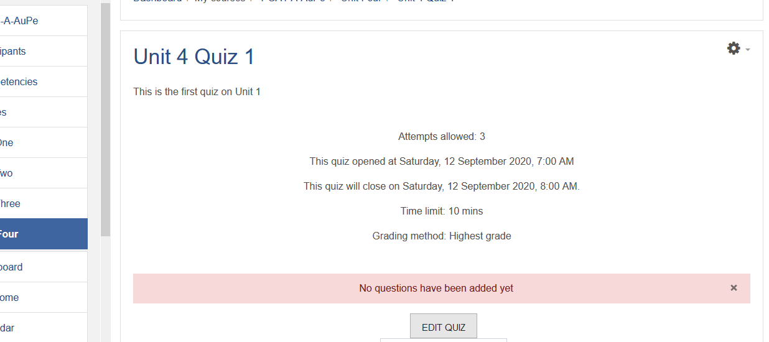

**Creating Questions from Scratch**

1. In order to create questions for the Quiz from scratch, select **a new question** option
2. Choose the type question (Figure ).

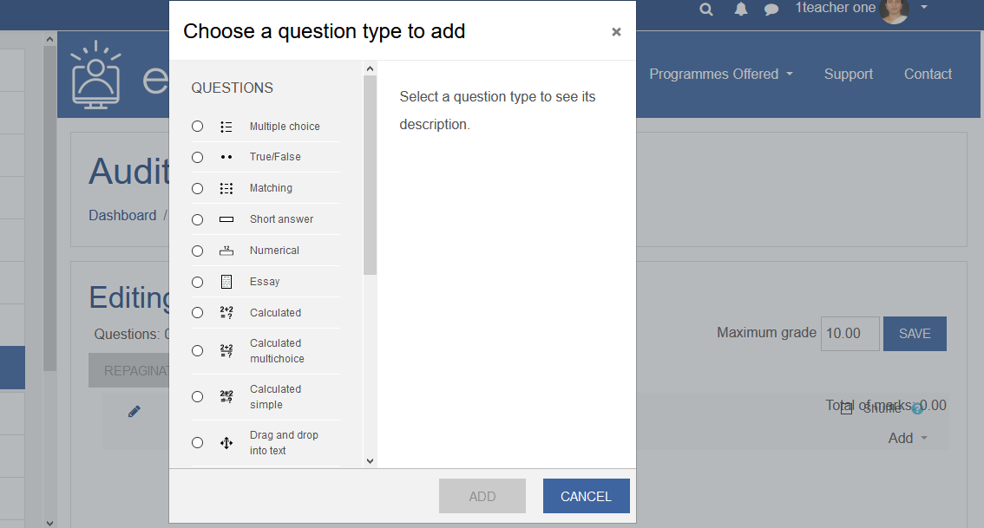

1. Depending upon the type of question, some of the settings will vary. However, the following settings are common for all types of questions.
2. **Category:** The new question by default will get created under a **Category** having the name of the course.In case you have divided the courses intoweek/ unit/ sections, and adding a new question in any of these, then that name also will be displayed as a category name in the pop-down menu under the **Category.** In fact, these categories are created simultaneously in **Question Bank** automatically while creating questions from scratch. A teacher can create his/her own categories and sub-categories in Question Bank and add a new question to that(More about is discussed under the heading **Question bank**)
3. **Question name:** Here enter a name for the question. **Remember, this is not the actual question. The question name will not be visible to the student.**The **name** of the question must be descriptive and meaningful(It can be the topic or subject or theme of the question)so that it can be easily identified later from a list of questions for teacher while editing quiz. Hence, names like Question 1, Question 2 etc. should be avoided. The actual question to be displayed to the student has to be entered in **Question Text** discussed below**.**
4. **Question text:**Enter the actual quiz question to be asked to the students here. The question text can be accompanied by an image which may be inserted from the computer. The image will be displayed for the student immediately after the question text and before the answer options. In addition to image, audio and video may also be inserted in the Question Text.
5. **Default mark:** Decide and enter the mark for the question. By default, the mark is ‘1’
6. **General feedback:** In **General feedback** the Teacher can explain more about the theme of the question and its answer in general irrespective of the answer given by the student. It is not based on the answer given by the student. i.e. Whether the student gives the right or wrong answer, the General Feedback will be the same. Here the teacher can also provide link to more information about the topic of the question. The General Feedback option can be left blank also.
7. **ID number:** Ignore this option
8. The remaining settings will vary depending upon the type of questions. The unique settings for Multiple-Choice Questions, True-False Questions and Short-Answer Questions are discussed below.
9. **Multiple-choice questions**

The multiple-choice questions (MCQs) are of two types: **single answer** and **multiple answer**. The question as well as answers can include image, sound or other media. The steps involved in setting up an MCQ are the following.

1. Choose the question type to add as **Multiple Choice.**
2. Enter the columns for **Category**, **Question name**, **Question text**, **Default mark**, **General feedback**, and **ID number**as discussed under **3a to 3f** above.
3. Choose whether students can only select one answer or multiple answers under **One or multiple answers?** The default is one answer only.
4. Also decide the answer options / choices should be **shuffled** during the next attempt.

**Note**: The shuffle option may be avoided in case one among the answer choice is **None of the Above.**

1. Choose the format for ordering the multiple answers i.e. 1,2, 3 / i, ii, iii etc.
2. Under **Answers**, in *Choice 1* provide one of the answer options that students can select.  Also, select a grade percentage for this answer from the pop-down menu. If it is correct answer then select**100%**and **None** for the wrong answer. There is also option for providing percentage-wise grade for partially right answers and negative marks for wrong answers. It is possible to add image, audio and video as a part of answer choices. Provide text-based feedback on the student’s selection of the choice. E.g. In case this is the correct answer, the feedback can be “Very good, Correct Answer” If the Choice 1 is a wrong answer the feed can may be “ Sorry, Your Answer is wrong” . Repeat the process for the remaining choices. By default, there are five choices. However, it is not mandatory that we have to fill all the choices. The choices left blank will be ignored and not displayfor the students during quiz. Also, if required more than five choices can be added by clicking BLANKS FOR 3 MORE CHOICES button. It is important to mark at least one of the choices as 100%, i.e, correct answer.
3. The **Combined feedback**is particularly useful for questions with Multiple Correct Answers. Here, the teacher can set general feedback for correct response (e.g. Your answer is correct), incorrect response (e.g. Your answer is wrong) and partially incorrect response (e.g. Your answer is partially correct). The **Combined feedback**option can be ignored.
4. **Multiple tries**: Optionally, the teacher can set a penalty for each incorrect attempt at the question, with hints to be displayed after each attempt.Hints are optional and can be applied to help the student figure out problems on their subsequent attempts.

**Note:**This option is applicable only when the *question behaviour* is set as ‘Interactive with multiple tries’ and ‘adaptive mode’.

1. The **Tag** is optional. But, helpful for the teacher assign key words pertainingto a specific question.
2. **True or False Questions**

In this type of question, the respondent selects from two options: True or False. The question can contain image, audio and video.

1. Choose the question type to add as **True or False**
2. Enter the columns for **Category**, **Question name**, **Question text**, **Default mark**, **General feedback**, and **ID number**as discussed under **3a to 3f** above.
3. In the **Correct answer** drop-down, select whether the statement is True or

False.

1. In the **Feedback for the** responsefields, enter the appropriate feedback for

both True or False

1. The **'penalty factor'** only applies when the question is used in a quiz using adaptive mode - i.e. where the student is allowed multiple attempts at a question even within the same attempt at the quiz.

**C.  Short-Answer Questions**

The Short-Answer Question requires the student to typea word or phrase as an answer. The question may include an image. Answers may or may not be case sensitive and can have more than **one correct answer**.The answer could be a word or a phrase, but it must match one of your acceptable answers exactly. It is better to keep the answer one-word to avoid missing a correct answer that's phrased differently.

1. Choose the question type to add as **True or False**
2. Enter the columns for **Category**, **Question name**, **Question text**, **Default mark**, **General feedback**, and **ID number**as discussed under **3a to 3f** above.
3. Choose whether the answers are **case-sensitive**.
4. Next, fill in the variations in/ varied versions of answers you will accept one by one and enter the grade for each. All the right answers may be given 100% grade. The alternate answers (e.g. usually different spellings or phrasingsthat you will also accept) you would enter these in answer fields. Also create feedback for each answer.
5. Decide penalty factor, if applicable

**Note**: The right answers should always be entered first and the wrong answer at last. ‘*’ can be used in place of wrong answers.

**D.  Matching Questions**

Matching questions requires students to choose corresponding items between two list of items provided. The items could be in the form of words, images or sounds. To avoid chance factor involved in matching the last one leftover item from either lists, it is necessary to enter a minimum of two question items on one list and three answer items on the other.

1. To begin with choose the question type to add as **Matching**
2. Enter the columns for **Category**, **Question name**, **Question text**, **Default mark**, **General feedback**, and **ID number** as discussed under **3a to 3f** above.
3. Beginning from the field for the first item, attach or type in an item e in the upper slot marked question and similarly the matching item in the lower slot marked answer as in Figure__.

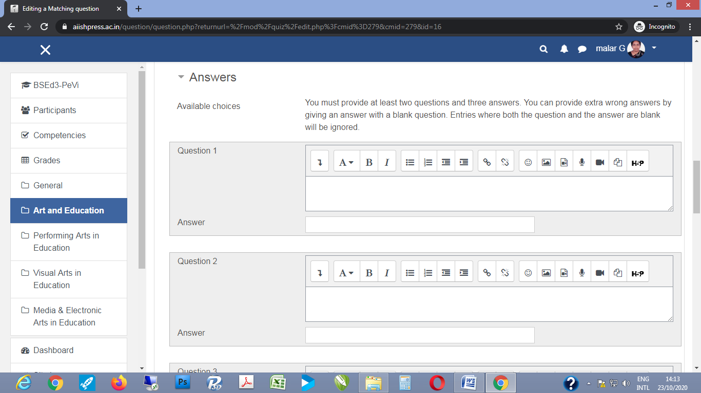

1. Initially, by default there space is provided to enter six items. However according to need three slots may be added in instalments to a maximum of 10 or more items.
2. How many ever the number of items, care should be taken to leave the question blank with only answer filled in the last item.
3. Check the 'shuffle' box if you want the answers in the drop-down menus to be shuffled.
4. Decide the penalty factor if applicable.
5. When the items appear to students, all question items will appear in a column on the left side. While all the answers are together listed in sequence in the form of a drop down menu to choose from against every question item as in Figure __.

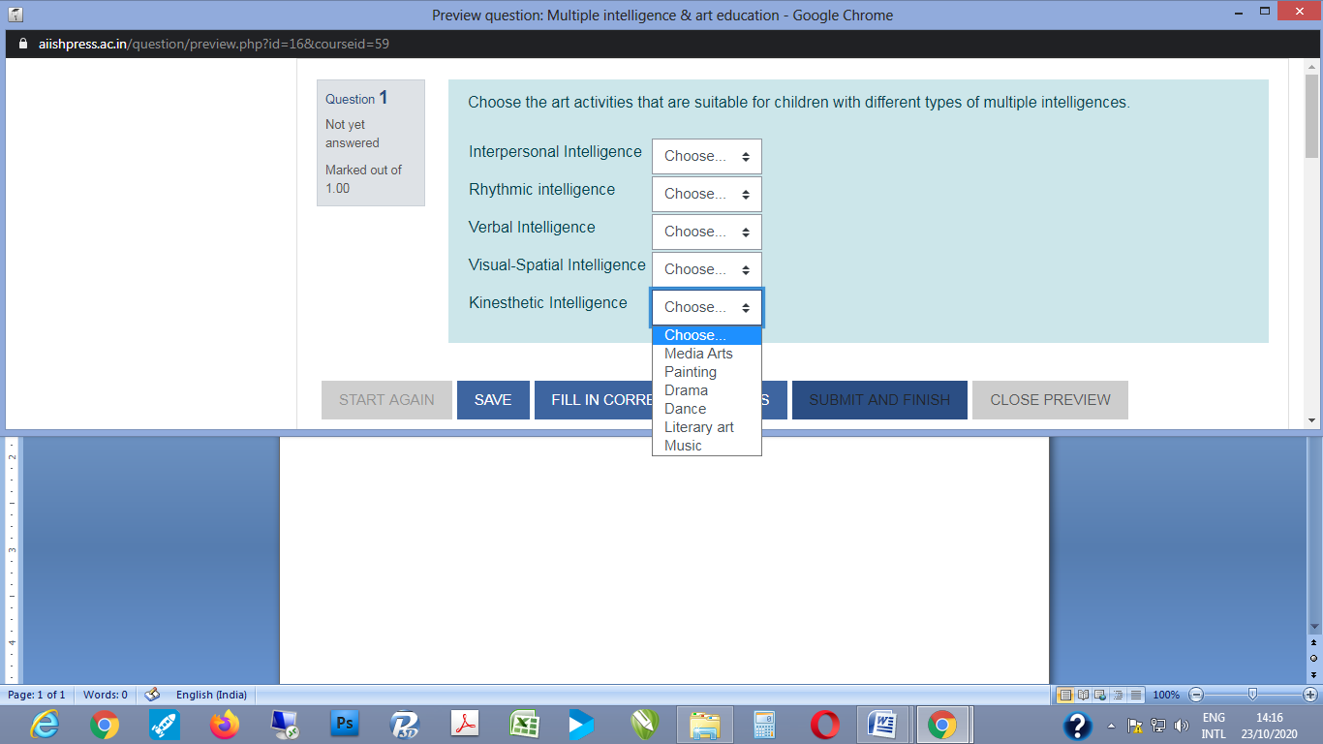

**E.  Essay Question Type**

Essay questions involve elaborate or long answers. They could be answered by entering text online, or uploading one or more files. However, assignment activity will be a better alternative for longer open-book and/or take-home essays, text or file uploads, etc. The process of creating or adding an essay question is similar to that of any other quiz item. However, the correction and scoring, that is, evaluation is not automatically machine generated like other objective items. The answers have to be individually reviewed and manually scored by the evaluator.

1. To set up an long answer type question choose to add an **Essay**.
2. Enter the columns for **Category**, **Question name**, **Question text**, **Default mark**, **General feedback**, and **ID number** as discussed under **3a to 3f** above.
3. You can choose between options of **Require text** for online entry of text, or **Text input optional** when answers are to be attached in the form of files.
4. In case of student entering text, you can choose the nature of text and related editing facilities. It could be plain text, if not choice of HTML editor is preferable. It allows students to custom-format font for effective appeal,
5. Further you can also specify the limit for the length of answer can be specified in terms of lines if the text is to be entered by students (Figure ).

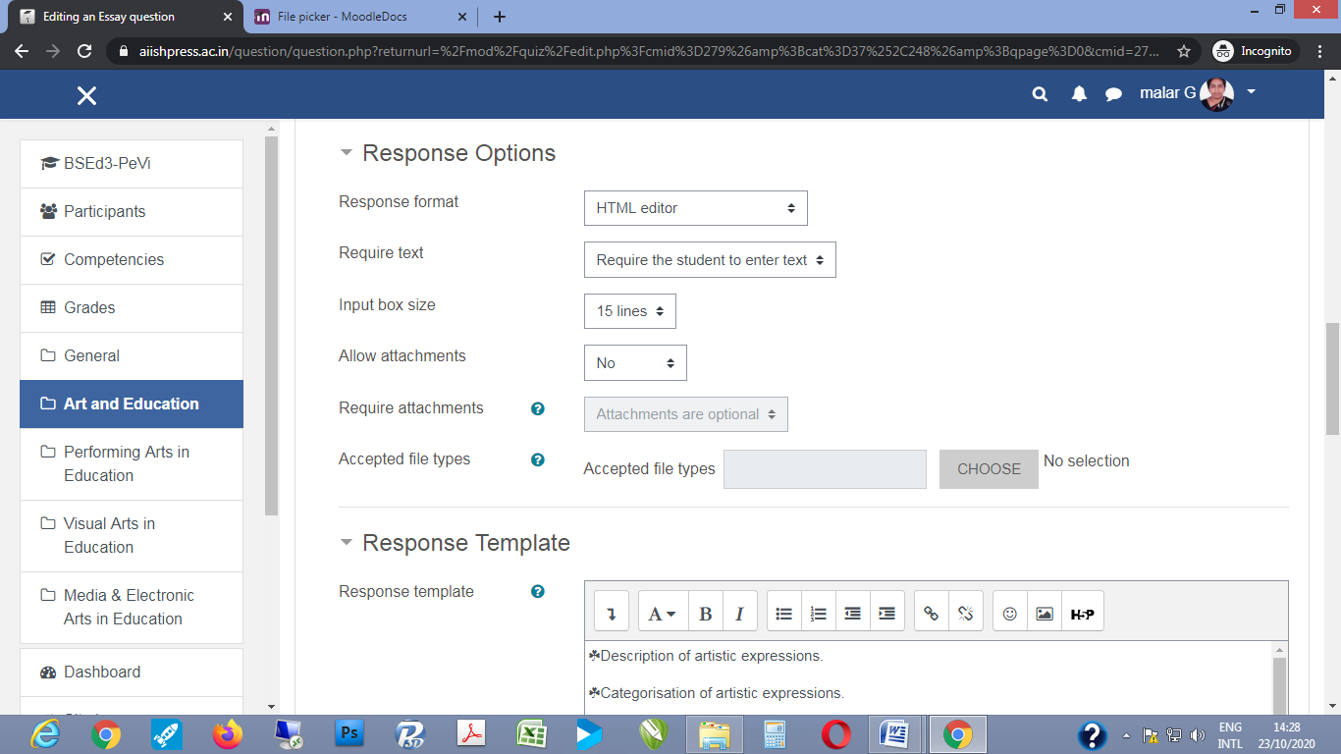

1. If you feel need to support students with some tips to answer, it can be provided it the form of a template. The template could take the form of hierarchical subheadings, or lead questions that are typed into the slot provided for answers.
2. As mentioned earlier as essay questions involve descriptive answers, they need to be checked personally and graded manually. Hence it is mandatory to choose the option of deferred feedback.
3. Deferred feedback provided to essay questions can include qualitative remarks and/or enriching information in the form text or other media files along with the scores.
4. Further if there is a possibility that the evaluator can be different from the question-setter, then it is better to leave a key for grading. A separate slot for Grader Information (Information for graders) is available for the purpose (Figure ).

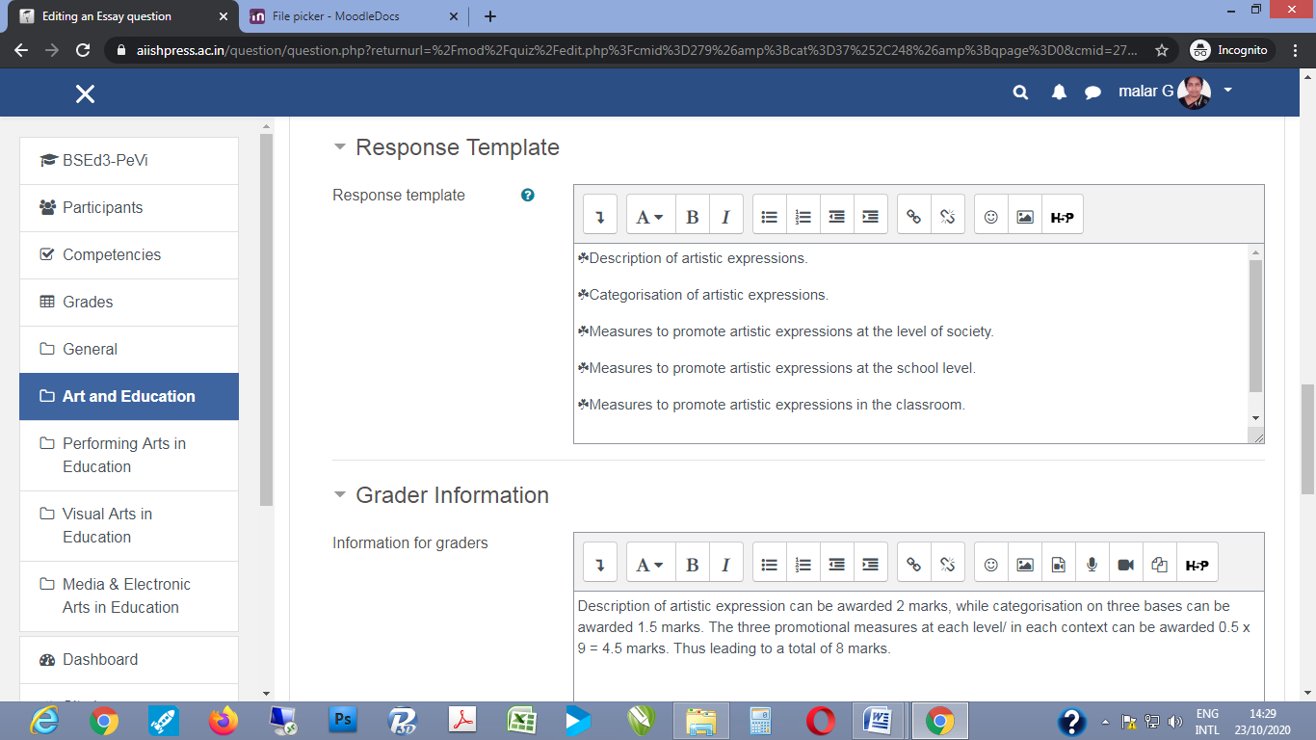

**F. Numerical Question Type**

A numerical question is an item that requires answer in the form of a number, especially if it involves a range of possible correct answers. For example, the average temperature of human body ranges between 36.1oC to 37.2oC, and where response with either one figure could be taken as correct.

1. As for the other quiz items choose to add the **Numerical** question type, and then enter the columns for **Category**, **Question name**, **Question text**, **Default mark**, **General feedback**, and **ID number** as discussed under **3a to 3f** above.
2. Then after fields for entering details of category name, question name, question in text, default mark, general feedback, ID number, etc. The fields for entering answers appear.
3. By default there are two slots available. The first one to enter the upper limit to the range of correct answer and the next for the lower limit respectively. However, if there are more possible answers like for the question ‘List the prime numbers less than 100’, then you can add more slots for answers in instalments of three.
4. In each slot, there is a field to enter a particular answer followed field to enter the error margin. For example, in the question about normal temperature, in the first slot the upper margin of 37.2oC could be entered with the error margin of -1.1ºC, while in the next slot the lower margin of 36.1oC could be entered with the error margin of -1.1ºC, or vice-versa (Figure ).

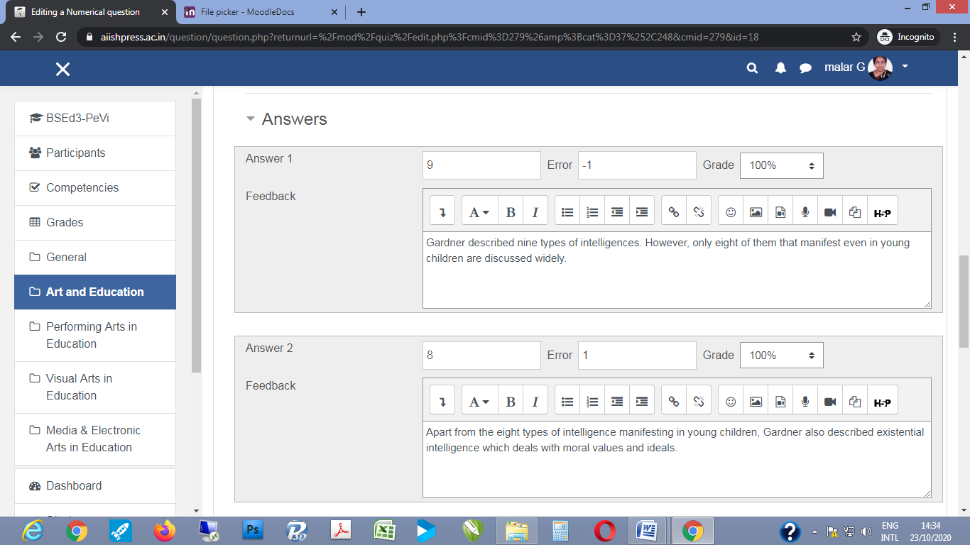

1. There are also other options to enter details about units in which the answer is to represented like that of length, weight, capacity, temperature, etc., and also to indicate the multiplier if answers will involve multiples of a root answer.

**F. Calculated Question Type (with or without Multichoice)**

Calculated questions are items that involve some kind of calculations or computations and result in numerical results, for example computing the area of a rectangle with the given length and breadth. Standard forms of such type of questions can be added to the question bank along with a range of wild card entries indicating the possible values for length and breadth. In the instance of selecting the question to add it to the constituents of a quiz, moodle will randomly assign variables from the wild card.

1. As for the other quiz items choose to add the **Numerical** question type, and then enter the columns for **Category**, **Question name**, **Question text**, **Default mark**, **General feedback**, and **ID number** as discussed under **3a to 3f** above.
2. After category name and before question name, question in text, default mark, general feedback, ID number, etc., there is an option for shared wild cards. The wild card entries have to be made by opening the Question Bank from the Moodle Dashboard.

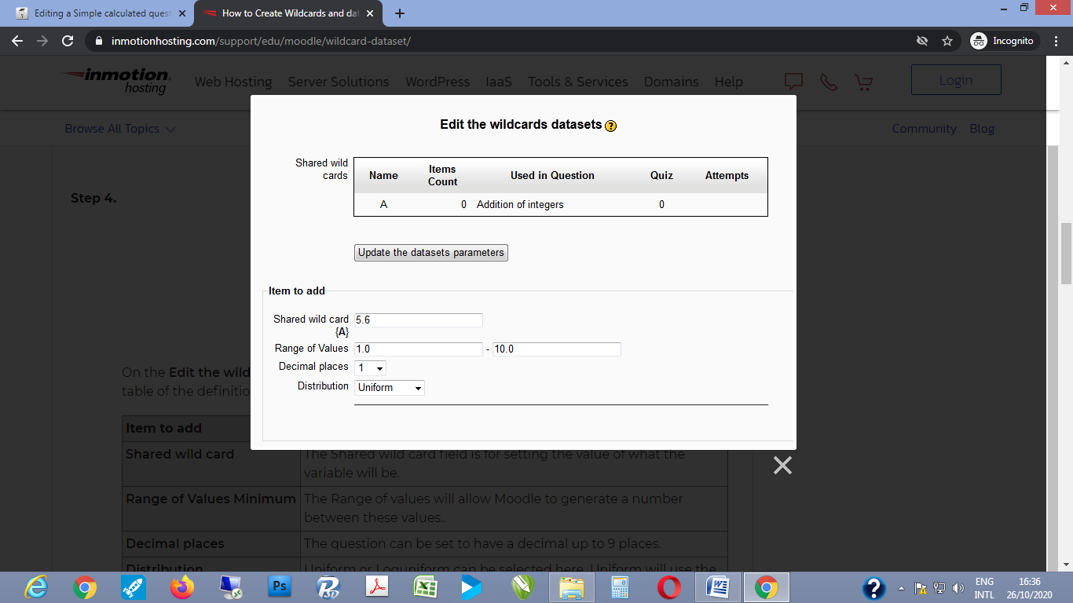

1. The field for entering question appears. In the question, you shall indicate the wild card number that has to be randomly generated from the question bank with {x}.
2. Following which you have to enter the formula for the correct answer as in Figure .

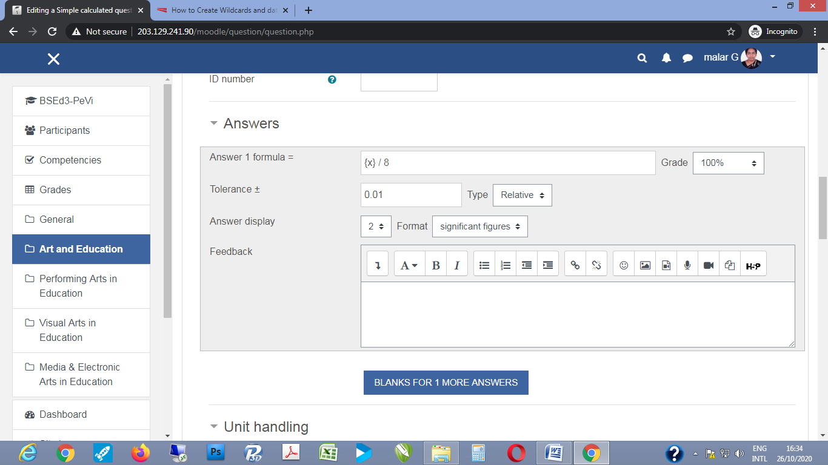

1. If you are permitting multiple trials for the question, hints may be provided to help students in the repeated attempts.

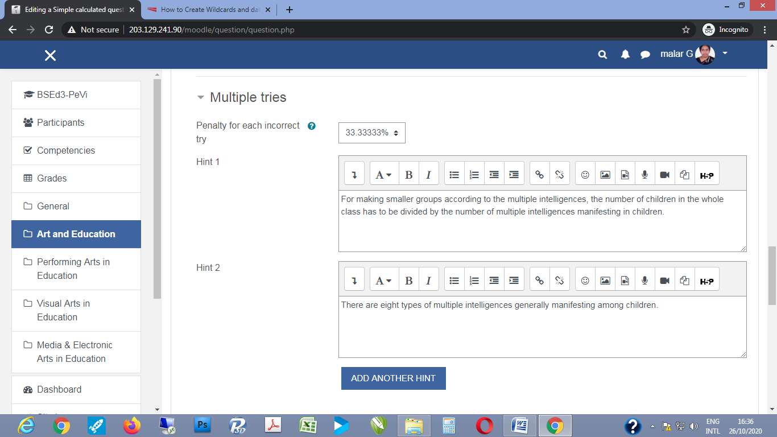

**G. Drag and Drop Question Types – into Text, unto Image, Markers**

Drag and drop questions are items for which answers in the form of text or images can be dragged and dropped into the slot for answering. These items could be considered as a variance of the multichoice questions.

1. As for the other quiz items choose to add the specific type of drag and drop question type – it could be **Drag and drop into text**, **Drag and drop onto image**, or **Drag and drop markers** question type, and then enter the columns for **Category**, **Question name**, **Question text**, **Default mark**, **General feedback**, and **ID number** as discussed under **3a to 3f** above.
2. For **Drag and drop into text**, the question is typed as passage or paragraph of text with the spaces where answers are to be inserted in-between are marked with double square brackets numbered consequently in their respective places, example [[1]], [[2]], etc.
3. In the space for answer the correct text to be inserted shall typed against the numbered code within the double square brackets.
4. If there are sub-groups or categories among your answers, like the organs affected in case of conductive or sensory-neural hearing loss, etc. there are options to colour code them which appear as drop down options besides the slots provided for answers.
5. There is also facility to indicate whether an answer may appear only once or may be used repeatedly.
6. For **Drag and drop onto image** question type, you have to create a background image as well as images to be dragged and dropped into it. For example the empty tract for speech sound production could form the background image, while the parts involved in respiration, resonation, articulation, etc. could be presented as images to be dragged and dropped. It is preferable to add a small text to tag the image in the allotted space.
7. Then the drop zones in the background zones have to be indicated by demarcating the space from the top-left of the image with x and y coordinates. Besides this demarcation indicate the drag and drop item that goes there with the name of the image and/or text-tag.
8. For **Drag and drop markers** question type, the students have to correctly locate specific regions in the question item, which is usual in the form of an image. For example, they may be asked to mark the region of oral cavity which is involved in production of specific vowels by pressing and dragging the cursor across the region in the background image.
9. For such question items, you need to insert the back ground image. Then the regions in the image corresponding to specific questions or textual labels or tags shall be indicated by noting relevant x and y coordinates.

**H. Embedded Answers (Cloze) Question Type**

Embedded or Cloze question types are in the form of a passage which incorporates several test items. These test items could be in the form of multiple choice, short answers or numerical answers.

1. As for the other quiz items choose to add **Embedded Answers (Cloze)** question type.
2. As usual enter the enter the columns for **Category**, **Question name**, **Question text**, **Default mark**, **General feedback**, and **ID number** as discussed under **3a to 3f** above.
3. It is suggested that **Excel-based [Cloze and GIFT Generator](http://hbwubecc.wixsite.com/jordan/tools)** or **Hot Potatoes Software** are easy means to prepare such combined test items and then you can import them into Moodle Quiz module.

**Adding questions from Question Bank**

The **Question Bank** is basically a folder to organize and manage questions so you have access to them for future use. It also allows the teacher to use **random questions** as well as re-use questions in later quizzes. In Question Bank, the questions are organized into **Categories** and **Sub-Categories**. It is a good practice to create questions in question bank and arrange them in categories and sub-categories so, that the teacher can conduct regular assessmentsconveniently by using these questions.

1. The **Question Bank** can be accessed in two ways: (a) From the **Gear** icon on the Course home page click **more** button which will take you to **Course Administration.** The default sectionof the Course Administration has two parts: **Reports** and **Question Bank** (Figure ) (b) From an already set up **Quiz activity** in a course click the **Gear** icon and select the **Question bank**listedat the end (Figure ).

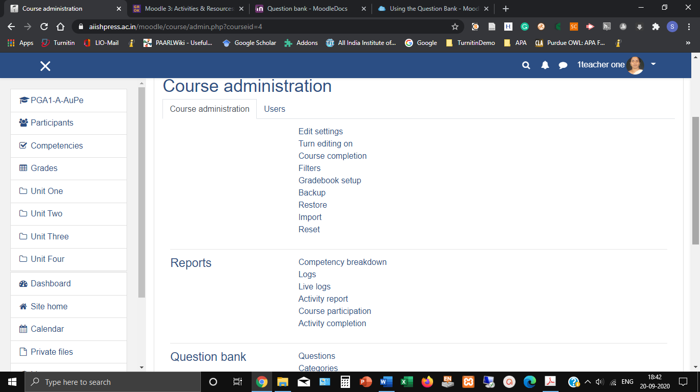

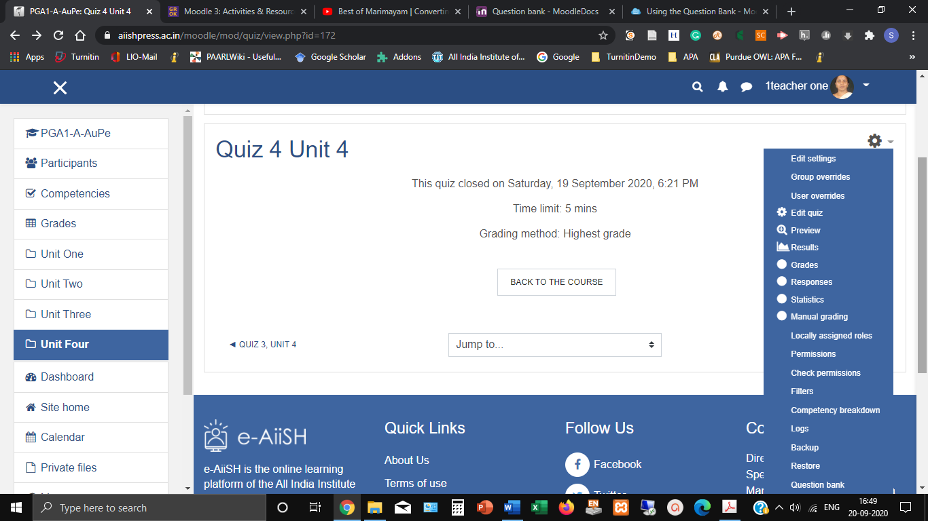

1. The Question Bank (Figure..) has four sections: **Questions**, **Categories**, **Import** and **Export.**

Under **Questions** section all the questions already created in the course including sub categories will be listed.**New questions** can be created (*as discussed earlier*) from here. Also, the existing questions can be tagged (include with keywords for searching), edited, duplicated, previewed and deleted. In addition, the questions can be **select**ed and moved to other categories and sub-categories. The questions can also be sorted here. The default sorted order is according to the Type of (**T**) questions.

The **Categories**Section facilitates the editing and moving of existing categories and adding new categories to the Question Bank

The Import and Export Sections facilitate importing and exporting the questions from and to different moodle compatible formats and platforms.

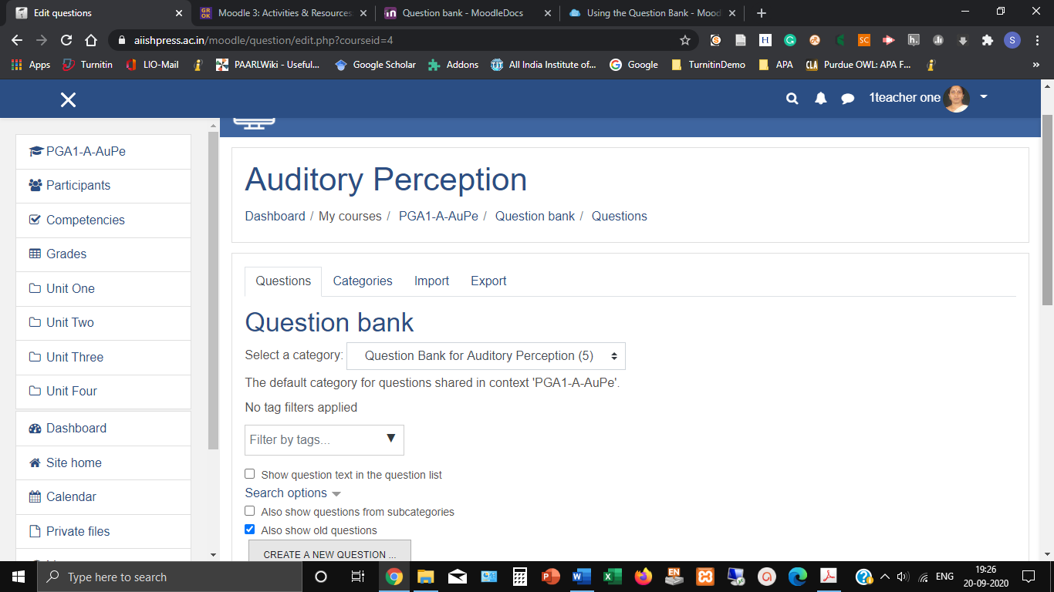

**Adding Random Questions**

The **Adding Random Questions**option facilitates the teacher to randomly pull questions from the question bank and create a quiz that is different for each student.  This option works best if the teacher has organized the question bank into categories.

1. Click the **gear** icon on the main quiz page and click the **Edit Quiz** option from the pop-down menu
2. From the resulting Edit Quiz window, click on the **Add**buttonat theright corner andselect **a random question** option.
3. Add the **required number of questions** from an **existing category** or **create a new category** and add by clicking the ADD RANDOM QUESTIONbutton.

**Attempting Quiz by the Students**

1. Once the teacher set up the Quiz, the student will get a notification regarding this with due date in the **Upcoming Event** section of the Course dashboard.
2. Upon clicking the link, the student will land at the entry page of the Quiz (Figure …) Click the ATTEMPT QUIZ NOWbutton.

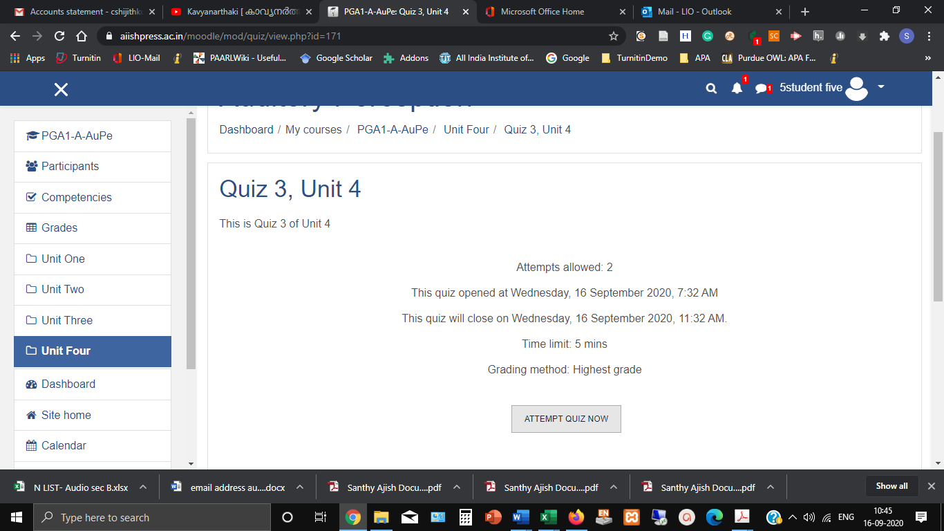

1. The system will indicate the time limit for completing the Quiz and ask for confirmation. The student has to click the START ATTEMPTbutton.
2. After completion, click FINISH ATTEMPTbutton.A Quiz navigation block can be seen on the right side.

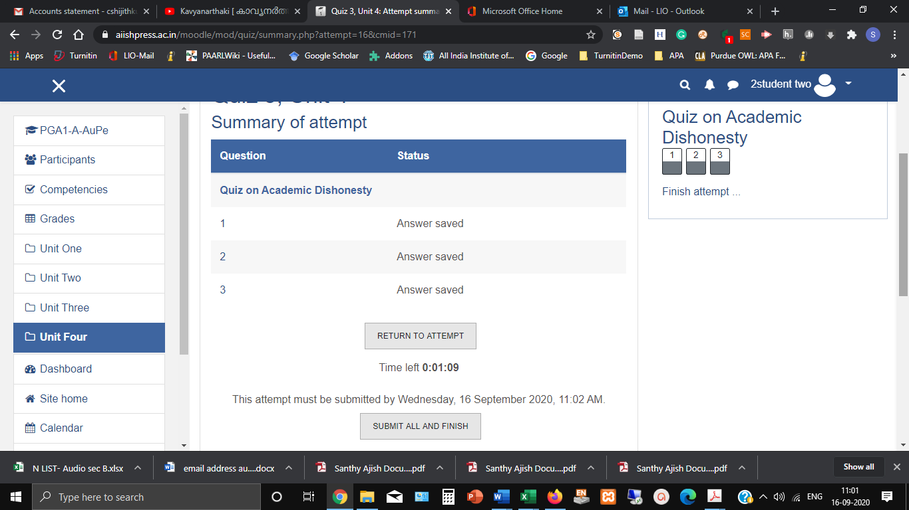

1. Now, the student can re-attempt the question by clicking the RETURN TO ATTEMPT button (This depends upon the number of attempts allotted by the teacher while setting up the Quiz) OR he can SUBMIT ALL AND FINISHthe attempt.
2. In case the student re-attempt the quiz, then the quiz will be displayed again. It will display with the answers he made during the previous attempts provided the teacher made the settings **build on previous attempt** .
3. In case the student opted the **Submit all and finish,** thenhe can **Review** theQuiz he attempted.After reviewing the student has to click **Finish Review** button and reach back the entry page of the Quiz from where he can re-attempt the Quiz, if required, as per the settings made by the Teacher.

**Note**

Once the students attempted the Quiz, the teacher cannot add or remove questions from it. However, the existing questions can be edited.

**Quiz Results / Reports**

After the students have attempted the quiz, the teacher can review the results/ reports by accessing the quiz name on the course page and clicking the **Attempts** button (Figure…) OR by clicking the **gear** menu and selecting **Results/ Grade/ Responses** link.

.

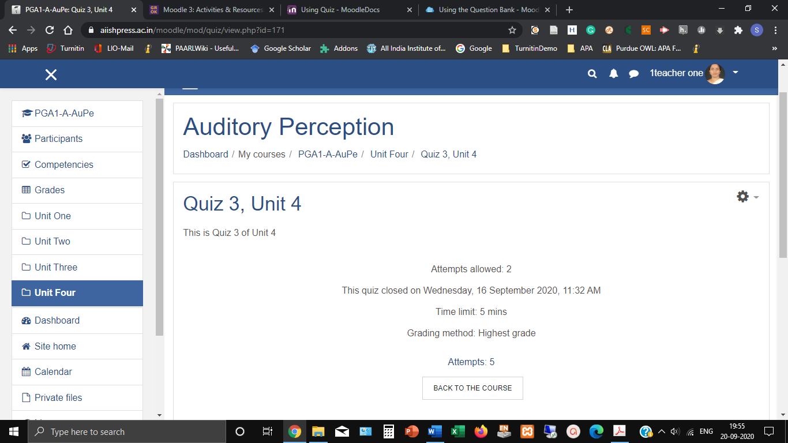

1. **View an individual student’s attempt**

From the **table**, click on the **Review attempt** link under the name of a student to open their attempt. Responses for each question attempted will be displayed, with full details of how the student responded, whether they changed a response and the marks allocated. As the teacher, you also have the ability to override the mark by clicking the Make comment or override mark link.

**Note**: Do not click on the student’s name. It will be taken to their profile

1. **Download results**

The results can be downloaded in pdf, html, csv, excel, JavaScript object notation and open document formats. From the **Download table data as** select the format and download the results.

1. **Delete attempts**
2. Click on the quiz link to enter the quiz.
3. Click on the Attempts link. The attempts area appears
4. Mark the attempts you want to delete, in this case as you want to delete allyou could also click **Select all**
5. Click **Delete selected**.

**Quiz Time extensions and Re-tests**

Sometimes students may need special consideration for online quizzes. Due to some technical issue or unavoidable genuine reasons the teacher has to give time extension or conduct re-test for a student.For this, there is a feature called **User Overrides** that allow individuals or groups to have alternativesettings to the class default.

1. Go to the Quiz main page and click the gear icon on the top right
2. Select the option **User Overrides**(figure ).

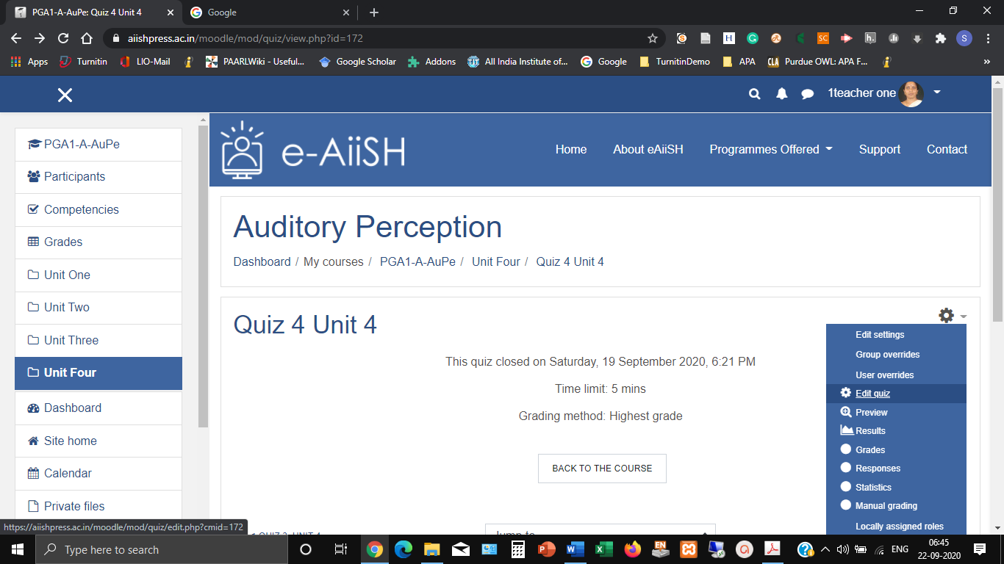

1. A blank screen appears with a single button, **ADD USER OVERRIDE**. Click the button to continue.
2. Search and Select the student(s) by clicking on their name.
3. Change quiz Opening and Closing, Time limit and attempts as required
4. Click save to apply overrides for the selected user(s).

**Note**: If creating an override for a student who has already attempted the quiz, remember to set the attempts to one higher than the existing number. Eg. If your quiz normally has two attempts, the override needs to be set to three, so the selected user gets one extra attempt.